Project Design Phase-I



**Solution architecture**

|  |  |
| --- | --- |
| Date | 20 October 2022 |
| Team ID | PNT2022TMID39129 |
| Project Name | A Novel Method for Handwritten Digit Recognition System |
| Maximum Marks | 4 Marks |

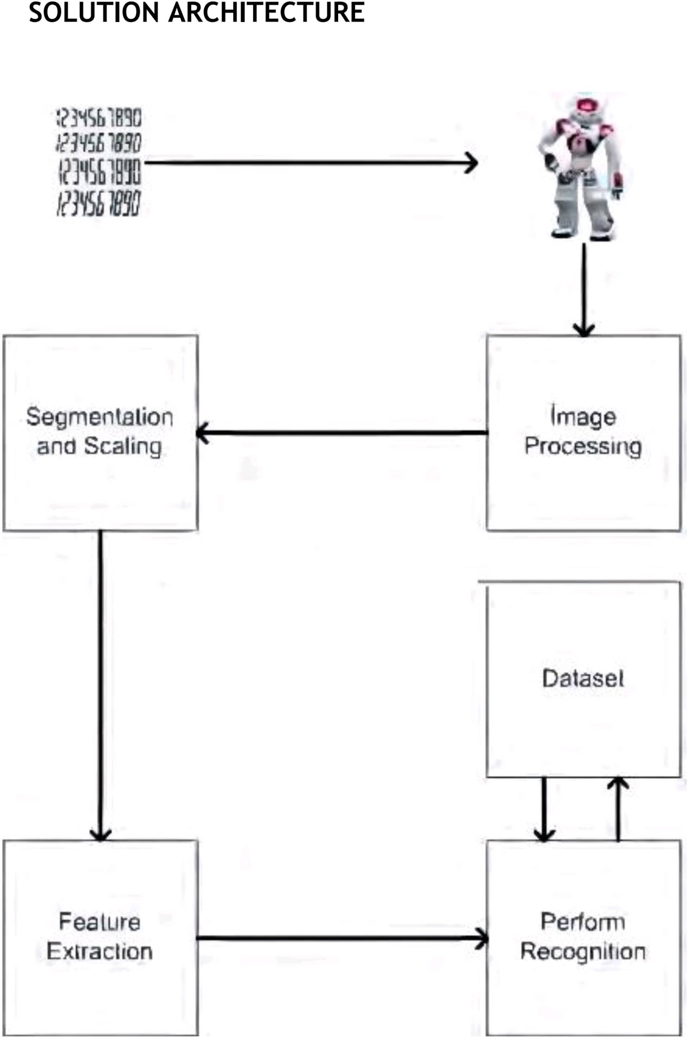

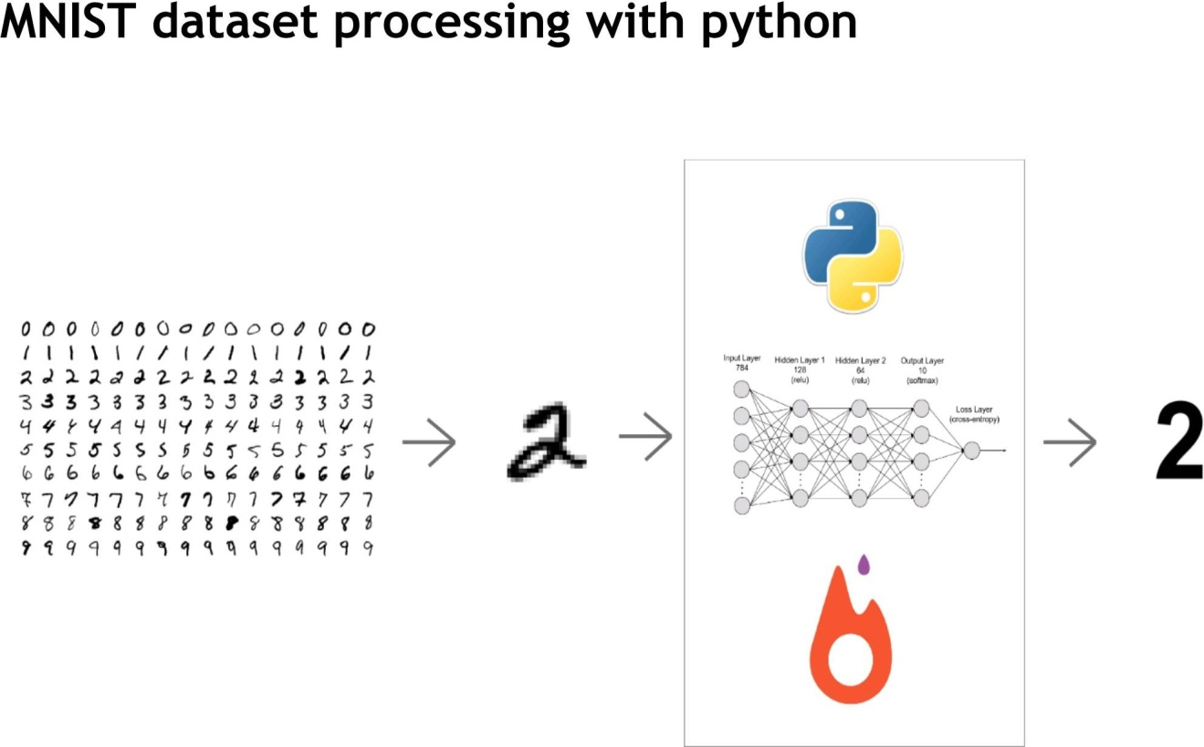

Overall architecture

